Great Golden round trip with Pearls of Switzerland
Exclusive Program for Braga Travel Consulting
Switzerland
10 nights / 11 days
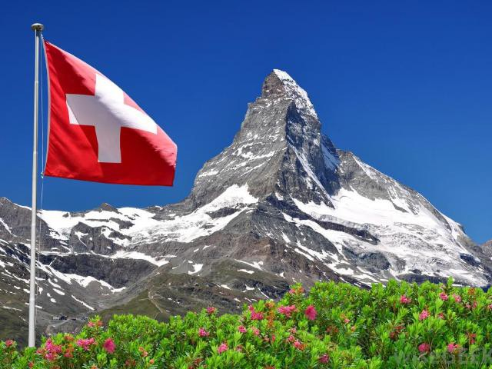
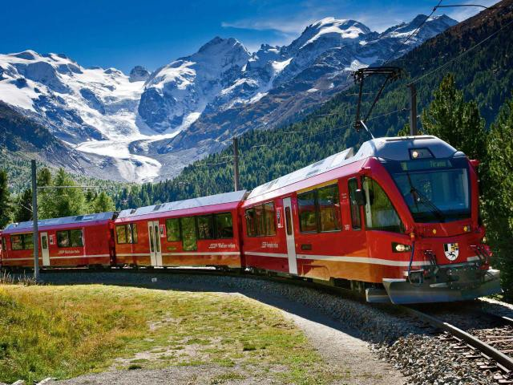

PROGRAM SUGGESTION:

Welcome, Switzerland

DAY 1
Lucerne

OVERNIGHT

Included:
- Breakfast
- 15-days Swiss Travel Pass - 1st Class
Arrival to Zurich airport. Train transfer from Zurich airport to Lucerne (approx 1 hr).
Public transportation is included in your Swiss Travel Pass, taxis would be your cost.

15-days Swiss Travel Pass - 1st Class.
Swiss travel pass includes train transfers throughout the whole of Switzerland.

Taxi transfers from TRAIN STATIONS TO HOTELS AND BACK (where needed) are subject to supplement.
Lucerne ranks amongst the world's prettiest cities, and there is so much to see. Contributing to Lucerne's cityscape alongside the world-famous Chapel Bridge and Water Tower are the Musegg Wall, the Jesuit Church, the Mill Bridge, the Lion Monument, the KKL culture and convention centre, and a host of other sites of interest.
The rest of the day free time for your own exploring and overnight.

Tip of the day
R E S T A U R A N T S & E V E N I N G R E C O M M E N D A T I O N :
If you are after new ways of serving and presenting food, then you must check this place out - Zur Verkstatt Restaurant. For local, more traditional cuisine: Stern Restaurant or Grottino with also Italian and Mediterranean cuisine.
For wide wine selection we suggest Opus Restaurant and if you want to spend Swiss dinner evening with folk’s music visit Stadtkeller Swiss Folklore Restaurant.

LUCERNE
HOTEL CENTRAL LUZERN 3*

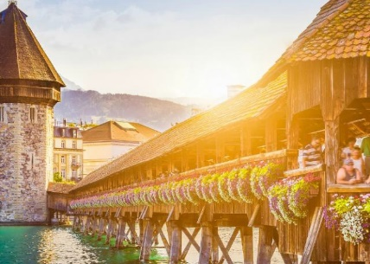
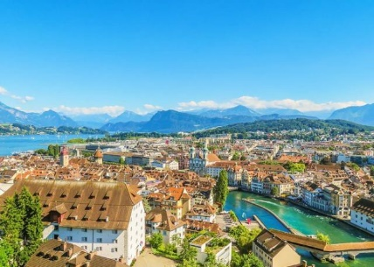
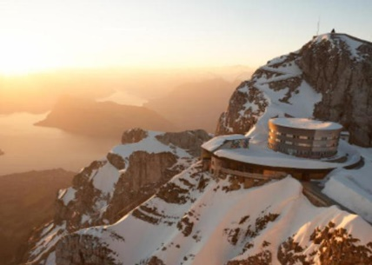
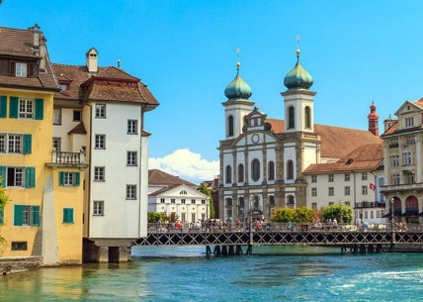
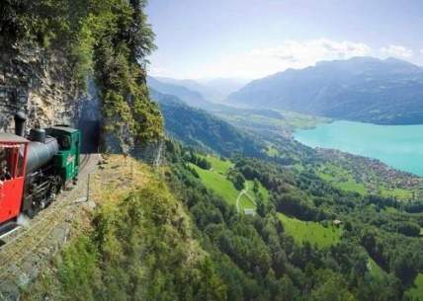
Lucerne with Mt.Pilatus and fascinating view

Included:
- Breakfast
- Mt.Pilatus Golden Tour

DAY 2
Lucerne
Mt. Pilatus Golden Tour - on your own without a guide: Maker of weather, dragon's lair, home to giants and grave of rulers: Lucerne's very own mountain, Pilatus, is one of the most legendary places in Central Switzerland. And one of the most beautiful. On a clear day the mountain offers a panoramic view of 73 Alpine peaks.
Even today Pilatus is a source of mystical discoveries and is home to places of natural beauty that are steeped in legend and lore. The mountain

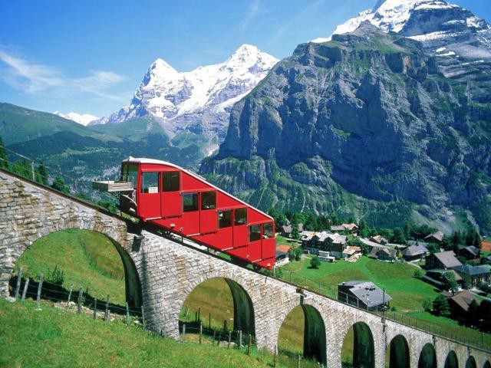
can be reached from Lucerne by gondola lift and aerial cable car and from Alpnachstad with the world's steepest rack-railroad. Thus a special roundtrip tour is possible, involving journeys by paddle steamer, rack-railroad, aerial cable car and bus. The trip can be combined with various types of sports or hiking tours.
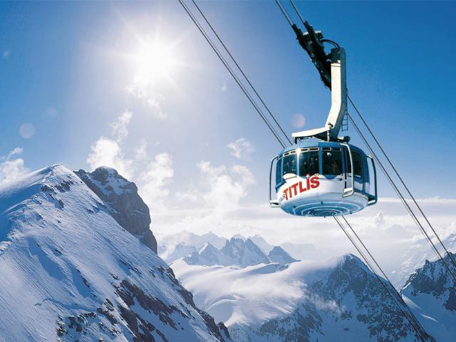
For those people who like boatrides and mountains, the Golden Roundtrip is a wonderful journey. To Alpnachstad by boat or train, then to Pilatus Kulm on the world's steepest railway. Descent by the cable car and gondolas to Kriens, Lucerne or the whole tour vice versa.

Tip of the day - other options in Lucerne area:
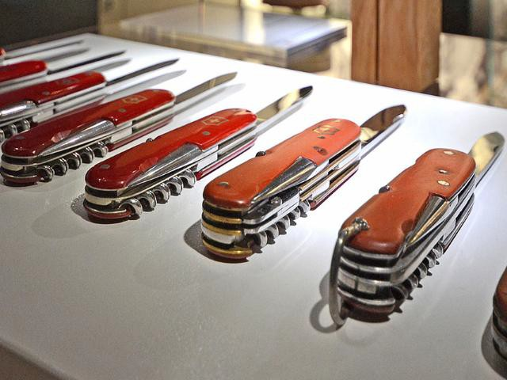
  - MT. TITLIS: The revolving gondola «Rotair» leads up to 9900 ft. into a breathtaking world of ice and snow. Titlis offers a variety of activities such as the „Ice Flyer“ (a chairlift over the glacier), the „Cliff Walk“ (Europe's highest suspension bridge), a visit to the glacier grotto or the snow park. . The tour can be combined with the fantastic 4-lakes hike (June-October).

  - CHOCOLATE MAKING & TASTING: First an
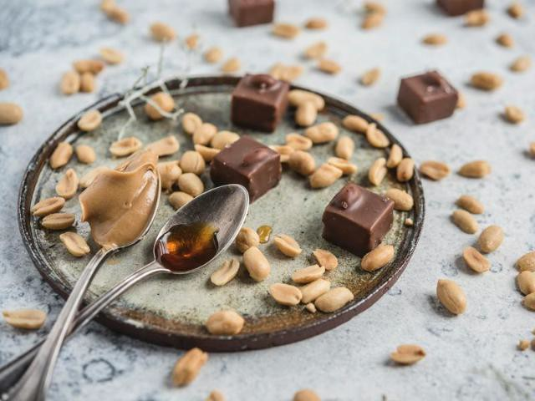
exclusive tasting, followed by chocolate making. Chocolate experts will take you on a journey into the world of cocoa and share their knowledge about the quality and ingredients of our chocolate treats with you. During the chocolate tasting, you will enjoy 6 – 7 seasonal treats and afterwards, you will be able to pour chocolate bars and stamp truffles yourself.
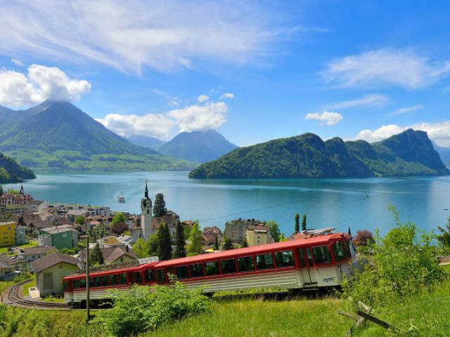
Available Mon-Fri. Duration: 90 min

  - MUSEUMS WORTH TO VISIT IN LUCERNE:
Museum Sammlung Rosengart (Rosengart Collection)and Swiss Transport Museum.

  - DAY OF HALF-DAY TRIP TO MT. RIGI: The
Rigi is a mountainous area near Lucerne. It's a typical Swiss green landscape with meadows, forests and grazing cows. Since 1871, it is well connected by cogwheel train. Rigi Kulm is the highest point (1798 m) with restaurant on the top and offers great views to Lake Lucerne, the Alps in the south and the plains in the north, all the way to Germany.

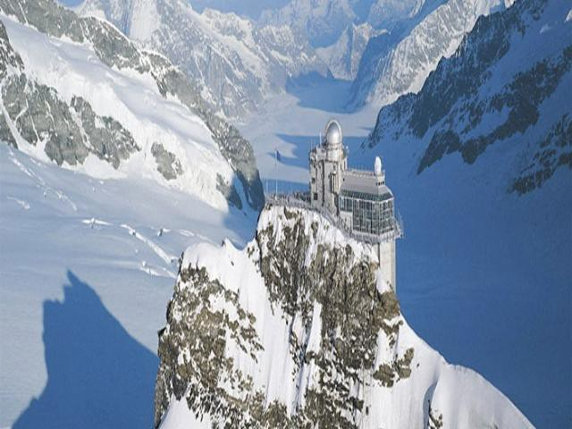
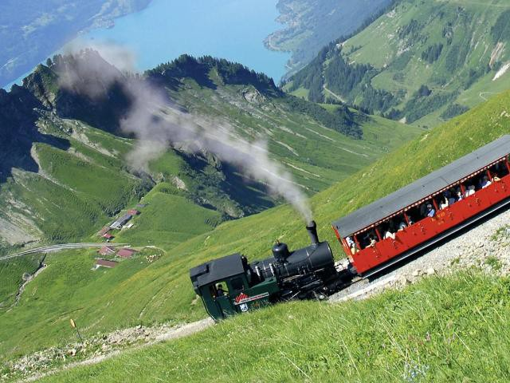
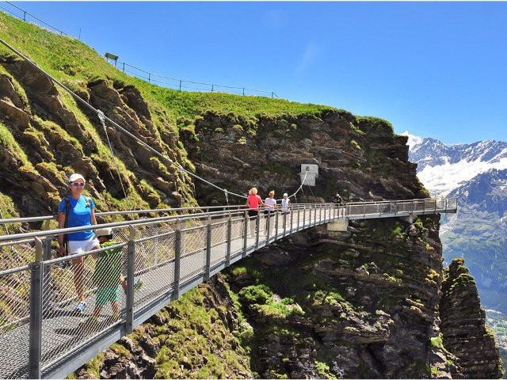
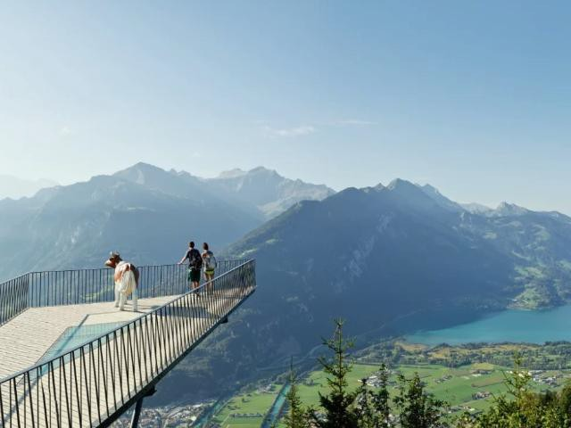
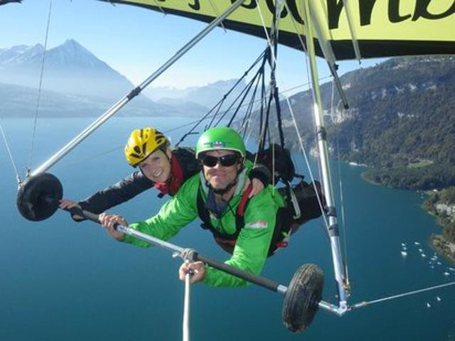

Interlaken - Top of Europe | DAY 3 OVERNIGHT  Lucerne - Interlaken - Grindelwald
Train transfer to Interlaken and further to
Grindelwald, check in at the hotel. GRINDELWALD
Continue with Top of Europe Experience: HOTEL CAPRICE 3*
Aletsch Glacier: Enjoy a 2 hour cogwheel train ride through green meadows and the hard rock of the Mountain Eiger to Europe’s highest railway station at 11,333 ft: the famous Jungfraujoch (Top of Europe).

Spend some time on top of Jungfraujoch which is covered by eternal ice and snow. You may visit the Glacier Palace with its ice sculptures, the Sphinx (weather station), and lookout platforms providing you with a breathtaking view of the glacier and the snow-covered mountain peaks.

Other options:
- TOP OF INTERLAKEN - HARDER KULM
viewing platform. If Interlaken had a king, he would reside on the Harder Kulm. From the viewing platform at 1,322 metres above sea level he would graciously look down upon Lake Brienz and Lake Thun, or admire the Eiger, Mönch, and Jungfrau. In fact, the Harder Kulm Panorama Restaurant is reminiscent of a castle.

- FUNKY CHOCOLATE MAKING WORKSHOP:
Funky Chocolate Club first opened in November 2014. Their love and passion for chocolate led them to this crazy idea – let’s open a meeting point for all chocolate lovers, let’s share secrets of Swiss chocolate with travelers from all over the world. Even though chocolate making is very serious business Funky Chocolate try to have as much fun as possible with all of their products.

- VISIT OF THE TRÜMMELBACH
WATERFALLS: The Trümmelbach Falls are the world's only glacier waterfalls that are accessible underground by lift, galleries, tunnels, paths and platforms. They are part of the Lauterbrunnen Valley's 72 waterfalls, among them also the imposing Staubbach Fall. The hiking tour on mainly flat land leads from Lauterbrunnen to Stechelberg, past water gushing from vertical rock faces that are several hundred meters high. Ticket of 11 CHF/person payable on the spot!
Included:
- Breakfast
- Train transfer to Interlaken
- Jungfraujoch train tickets + seat reservations

Bern, the capital of | DAY 4  Grindelwald, Interlaken, Bern, Montreux | OVERNIGHT
Switzerland and to
 | Train transfer from Grindelwald to Bern. Leave your luggage in the train station lockers and explore Bern, the capital of Switzerland.  Explore historical Bern, the capital city of Switzerland on your own. Stroll through the beautiful and romantic old town, a UNESCO World heritage site of Bern. The Old City (Altstadt) is the medieval city center of Bern, Switzerland. Built on a narrow hill surrounded on three sides by the river Aare, its compact layout has remained essentially unchanged since its construction during the twelfth to the fifteenth century. Despite a major fire in 1405, after which much of the city was rebuilt in sandstone, and substantial construction efforts in the eighteenth century, Bern's old city has retained its medieval character.  It is a home to Switzerland's tallest cathedral as well as other churches, bridges and a large collection of Renaissance fountains. In addition to many historical buildings, the seats of the federal, cantonal and municipal government are also situated in the Old City. It is a UNESCO Cultural World Heritage Site since 1983 due to the compact and generally intact medieval core and is an excellent example of incorporating the modern world into a medieval city. Numerous buildings in the Old City have been designated as Swiss Cultural Properties of National Significance, as well as the entire Old City.  In late afternoon, train transfer to Montreux. Check-in at the hotel and at leisure.  Tip of the day - options in Bern:  - OMEGA WATCH MUSEUM: Ground-breaking innovations, space travel, precision records, deep- sea adventures, Olympic Games timekeeping, James Bond – OMEGA’s legacy is truly extraordinary and the brand’s beautifully modern Museum near Bern is a fitting place to tell such an extraordinary story. Museum is located outside of the city center so public/private transportation is needed for arrival and return.  - BERN HISTORICAL MUSEUM: one of the most important museums of cultural history in Switzerland. The collections of archaeology, history and ethnography include approximately 500,000 objects dating from the Stone Age to the present and representing cultures from all over the world. THE INTEGRATED EINSTEIN  MUSEUM offers an account of the life and work of the physicist and places it in a fascinating | MONTREUX  EUROTEL MONTREUX 4*  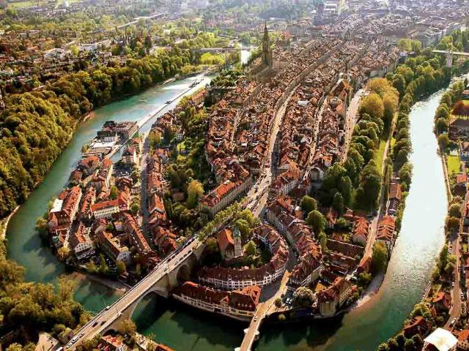  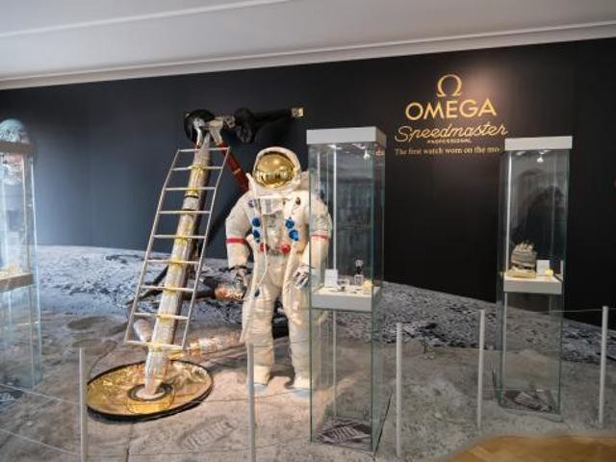  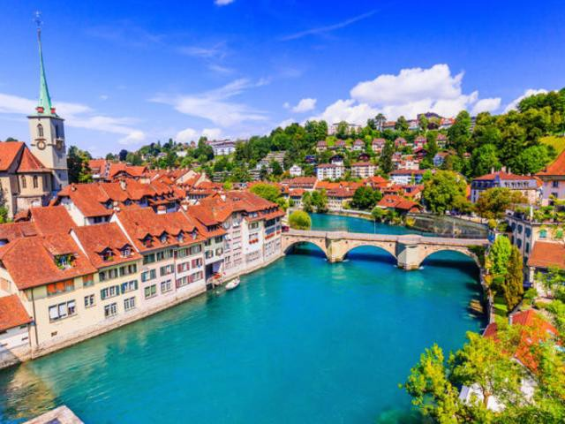  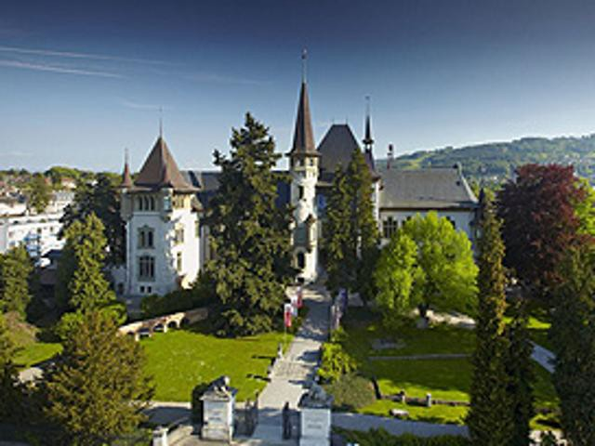  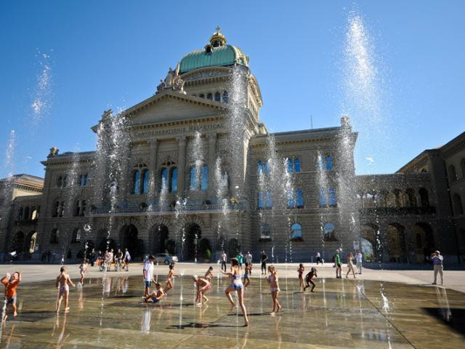
Lausanne by Geneva
Lake
Included:
- Breakfast
- Train transfer to Bern
- Train transfer to Montreux

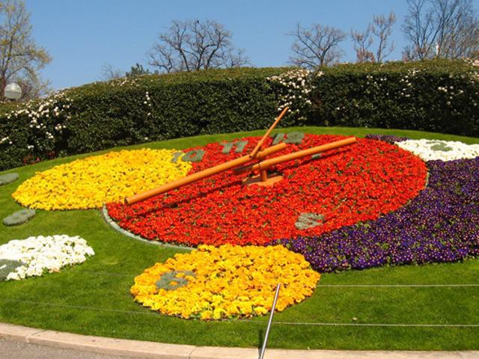
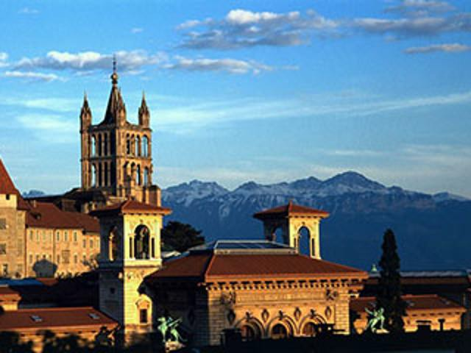
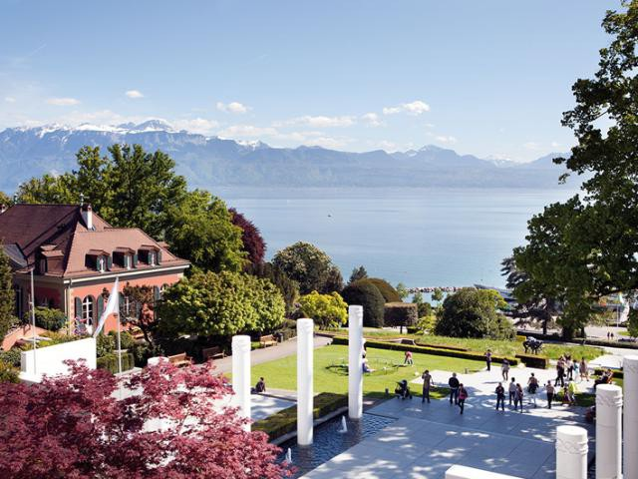
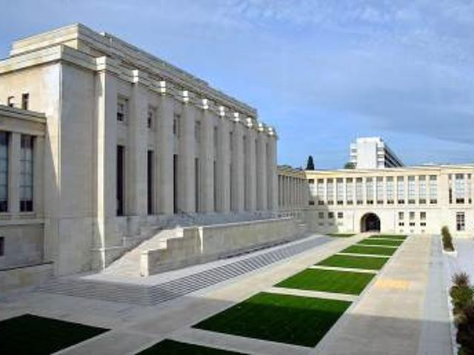
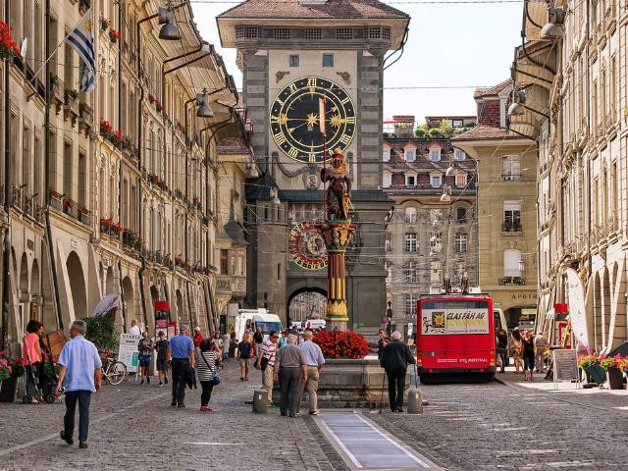
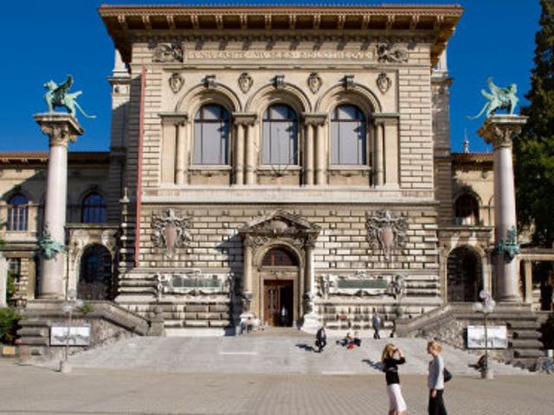
manner in the context of world history (separate entrance fees).

Geneva Lake: Castle Chillon with Montreux & Chic Lausanne | DAY 5  Montreux, Lausanne, Geneve
Visit Chillon Castle, located on a rock on the banks of Lake Geneva. The water castle is the most visited historic building in Switzerland. For nearly four centuries Chillon was the residence and profitable toll station of the Counts of Savoy.
Train transfer to Lausanne.
Explore Lausanne on your own: As a base of International Olympic Committee since 1914, Lausanne is boasting as second largest town by Geneve Lake. The setting of Lausanne is extremely picturesque: the town is built on three hills, surrounded by vineyard-covered slopes, with Lake Geneva at its feet. Rising impressively from the opposing French lakeshore are the Savoy Alps. The attractive old town is largely car-free. Small alleyways with cafes and boutiques shape the streetscape in the medieval city centre.
Also worthy of a visit are the parks, containing many Mediterranean plant species, and grand palace hotels like the Beau-Rivage Palace in Ouchy and the Hotel de l'Angleterre, where Lord Byron once stayed.
Included:
- Breakfast
- Entrance fee to Castle Chillon
- Train transfer to Lausanne
- Train transfer to Geneva
 | Train transfer to Geneva.
Explore Geneva on your own: Geneva is a truly one-of-a-kind city in the heart of Switzerland. The center of diplomacy, high business and luxury, also rich in history, surrounded by beautiful nature.
The symbol of the «world’s smallest metropolis» is the “Jet d’eau” – a fountain with a 140-metre-high water jet at the periphery of Lake Geneva. Most of the large hotels and many restaurants are situated on the right-hand shore of the lake. The old town, the heart of Geneva with the shopping and business quarter, holds sway over the left-hand shore. It is dominated by St. Peter’s Cathedral, however the actual centre of the old town is the Place du Bourg- de-Four, which is the oldest square in the city. Quays, lakeside promenades, countless parks, lively side streets in the old town and elegant shops invite guests to stroll.
 | Return to Montreux.
Instead of Lausanne and Geneva:
- LA GRUYERE CHEESE AND CHOCOLATE
DAY: Discover the region of cheese and chocolate and enjoy medieval town of La Gruyère. Visit chocolate and cheese production factories. Enjoy also a relaxed walk through Gruyeres village with charming medieval Castle.

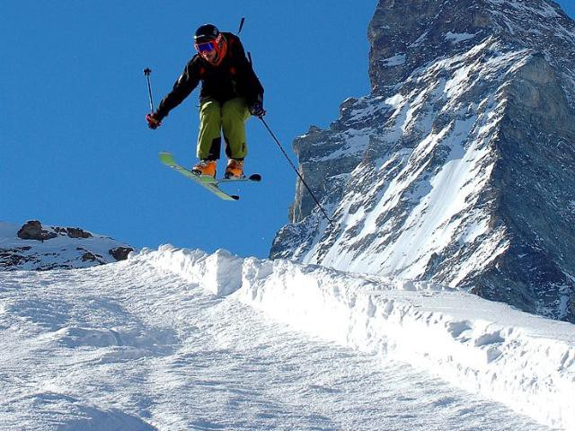
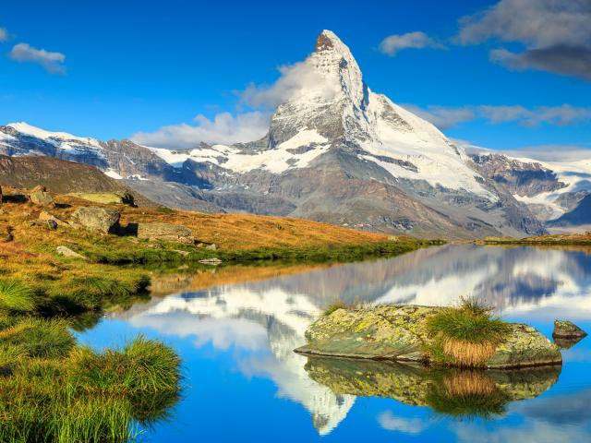
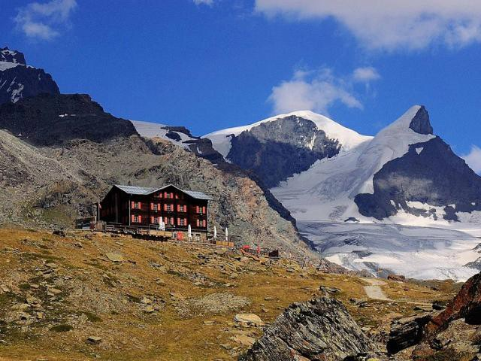

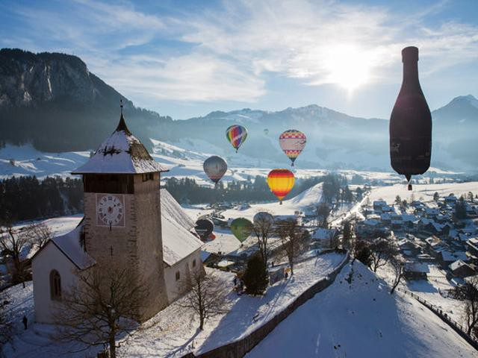
  - COOKING CLASS IN VEVEY: Since year 2006,
Atelier Cuisine has been passing on the passion for cooking within a cozy and unique atmosphere with the accent on friendliness and eating as a gourmet.
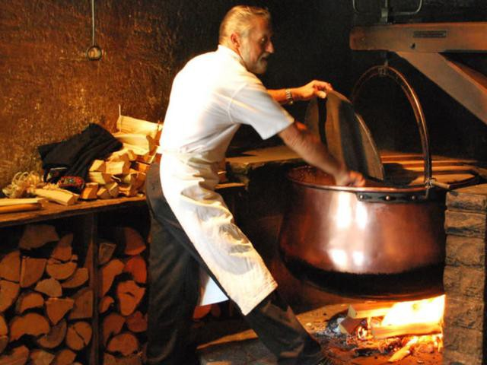
You will cook together before sitting down to eat with you and to taste the dishes we prepared.

  - THE CHÂTEAU D'AIGLE WITH THE VINE
AND WINE MUSEUM: beautifully surrounded by vineyards in the Rhone Valley just minutes away from Lake Geneva. The Vine and Wine Museum (Musée de la vigne et du vin) inside Aigle Castle has a collection of historical implements used in the wine-making process but also numerous interactive displays in making of wine. The views of the vineyards from the castle are absolutely divine.

Zermatt & Mountain | DAY 6  Montreux - Zermatt | OVERNIGHT
View of the World - Mt. Matterhorn Glacier
 | Train transfer from Montreux to Zermatt. ZERMATT
Included:  - Breakfast  - Train transfer to Zermatt  - Return ticket for Cable car to Matterhorn Glacier Paradise | After check-in, ascend by cable car to the top of ARCA SOLEBAD WELLNESS  Matterhorn glacier Paradise, set on a high & SPA 3* plateau and surrounded by mountains 13,124 feet  high. Fantastic highest viewing platform in Europe (3883m) – one of the best views I have ever seen in my life! Take a hike or ski on the glacier, offering numerous ski-lifts to enjoy skiing.  Rest of the day at leisure in Zermatt, famous because of the best view of the impressive Matterhorn. The rural village with the dark sun- burned wooden houses is inviting for shopping and fine eating.
 | Enjoy free time in Zermatt and have a great dinner in one of numerous restaurants.
 | Tip of the day in Zermatt:
 | GORNERGRAT VIEW POINT: The Gornergrat
 | railway is a mountain rack railway, it links the
 | resort village of Zermatt, situated at 1,604 m above
 | sea level, to the summit of the Gornergrat. Enjoy
 | another fascinating viewpoint from Gornergrat. The
 | Gornergrat (3,089 m) is one of those places that
 | everyone should visit at least once in a lifetime. The
 | mountain panorama and the glorious view of the
 | Matterhorn is unforgettable.

World famous Panoramic Glacier Express Train | DAY 7 OVERNIGHT  Zermatt - St.Moritz
Enjoy a full day on the Glacier Express, most
renowned Panoramic Train in the world from ST.MORITZ
Zermatt to St.Moritz. Sit back and relax in your UNIQUE HOTEL EDEN comfy seat, taking in the Alpine scenery from the SUPERIOR 3* large picture windows and enjoying a delicious
lunch served at your seat.
Included:
- Breakfast
- Glacier Express Train

Zurich

Included:
- Breakfast
- Train transfer to Zurich

DAY 8
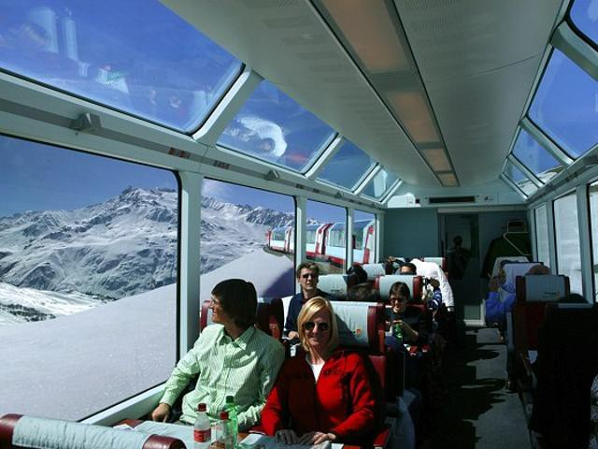
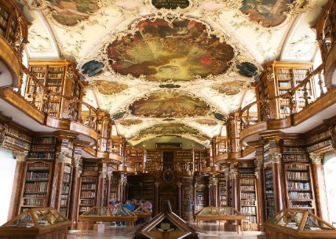
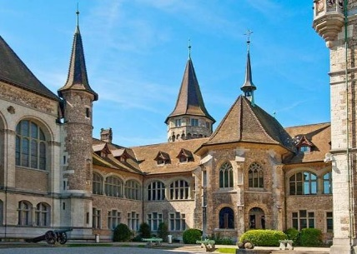
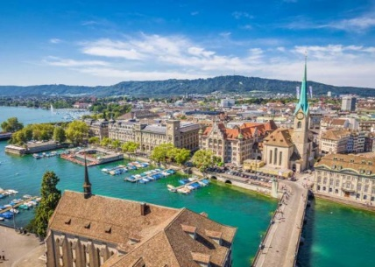
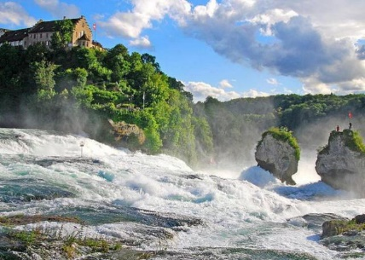
St.Moritz - Zurich
Train transfer to Zurich.
Explore Zurich on your own. Discover the spectacular sights of Zurich, one of most vibrant Swiss city. Cruise past legendary landmarks like the sophisticated Bahnhofstrasse and admire the shimmering surface of Lake Zurich. See, too, the sacred St Peter’s Church and the charming Old Town, and then ride the Dolderbahn railway to the undulating hills of the Zurichberg district.

Tip of the day - more options for Zurich:
- ZURICH FOOD TOUR: On the Zurich Food Tour, gourmets visit on foot restaurants and bars that are particularly popular among the locals. The tour provides an insight into the eating and drinking culture of Zurich’s inhabitants. Beside tasty appetizers made from vegetables, meat, fish or seafood, a selection of alcoholic beverages are served – including freshly brewed Zurich beer.

OVERNIGHT

ZURICH
HOTEL ADLER ZURICH 3*

Free day or Romantic towns of Switzerland

Included:
- Breakfast
- Train transfer to Basel
- ZURICH CHOCOLATES AND SWEETS SMALL GROUP WALKING TOUR: See the
sweet side of Zurich on a tour of Old Town’s finest chocolatiers, candy shops, and artisan ice cream makers. Perfect for those who want to indulge their love of Swiss chocolate, the tour includes samples aplenty and gives you the lowdown on treats from a local food writer and chocolate enthusiast.

DAY 9
Zurich
Train transfer to Basel.
Explore Basel on your own. Sitting astride the Rhine River near the French and German borders in Northwest Switzerland, the city of Basel boasts a beautiful historic core and the country's highest concentration of galleries and museums. It is also

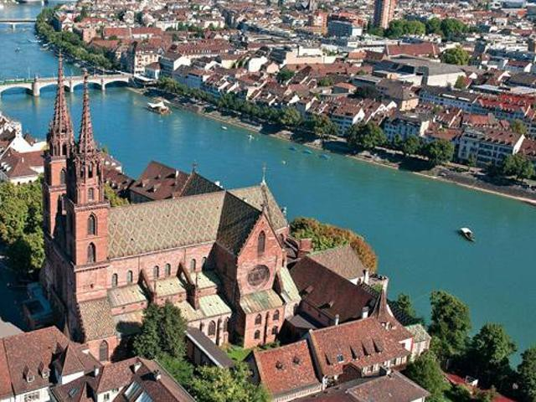

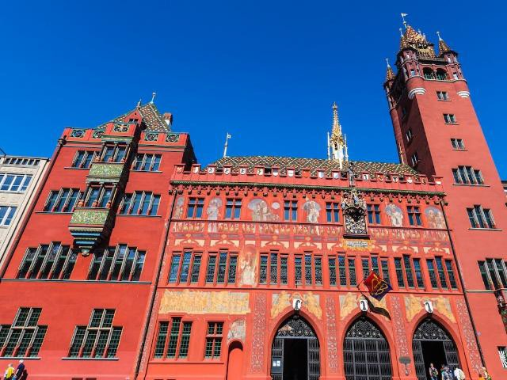
Switzerland's oldest university city. Historic landmarks of the city include the large market square with its richly decorated red sandstone town hall and the late Romanesque-Gothic cathedral.

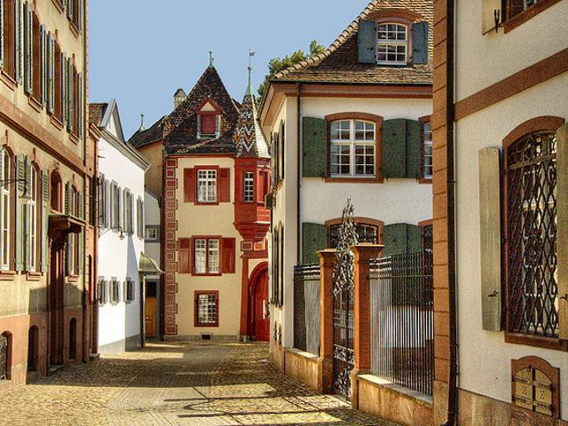
Return back to Zurich.

Appenzell region | DAY 10  Zurich
Included:  - Breakfast | Train TRIP TO APPENZELL:  it is a town with the car-free center features wooden houses with colorful facades. Trails and cableways connect various summits, including towering Säntis peak. On the steep cliffs of the Ebenalp, the Wildkirchli cave complex houses a 17th-century chapel and hermitage. Nearby is the old Aescher inn, tucked into the side of a sheer cliff. Very renowned is also Appenzeller cheese where you can visit also cheese factory.  You can also stop at St. Gallen and visit famous Abbey Library.
Bye, Bye Switzerland | DAY 11  Zurich
Included:  - Breakfast  - Train transfer to Zurich Airport | Train transfer to Zurich Airport and flight back home.

Inclusions & Exclusions specific to your tour

Inclusions:
  - 10x accommodation in rooms with breakfast as stated above.
  - Transportation, guides and entrance fees as per left-column side in the itinerary.
  - Organization
  - VAT

Exclusions:
  - All international air travel and associated costs.
  - All meals except breakfast unless stated otherwise in the itinerary.
  - Porterage
  - Gratuities
  - City/tourist taxes are payable on the spot at each accommodation upon check-out (amount is normally between 1-5 USD/person/day, depending on hotel and location).
  - All items of a personal nature (e.g. beverages, telephone calls, laundry, personal insurance).
  - Anything not specifically mentioned in the “Inclusions” list above.

HOTEL RECOMMENDATIONS:

LUCERNE : HOTEL CENTRAL LUZERN 3*
https://www.hotel-central-luzern.com/en/ Booking.com review (2018-10-17): 8.9/10
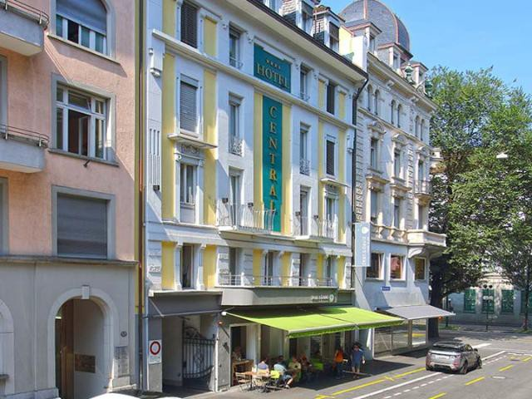
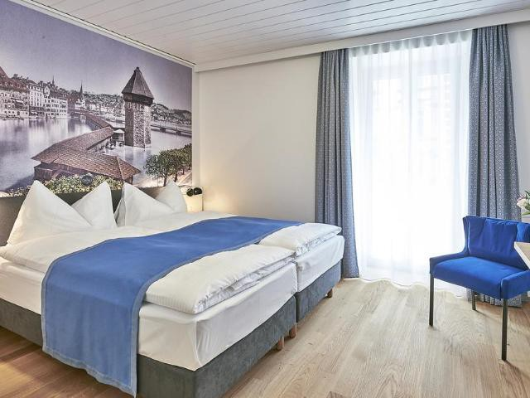
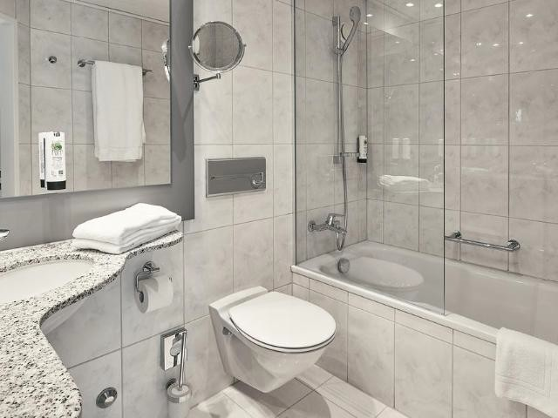

Set right in the heart of the bustling Neustadt quarter in the centre of Lucerne, the newly opened neoclassical city Hotel Central Luzern enjoys a quiet location in a side alley, with modern rooms and free Wi-Fi.

All of the bright and newly refurbished rooms are non-smoking and feature parquet floors, a flat-screen TV and a radio. The en-suite bathrooms are equipped with a hairdryer and free toiletries. A rich buffet breakfast with regional products is included in all rates. Guests can relax in the hotel lounge and enjoy free tea, coffee and water in a comfortable atmosphere.

Paid public parking spaces are available in the surroundings.

The main train station, the KKL Culture and Convention Centre Lucerne, Chapel Bridge and the old town are all reachable within easy walking distance.

GRINDELWALD: HOTEL CAPRICE 3*
https://www.hotel-caprice.ch Booking.com review (2019-11-22): 8.9/10
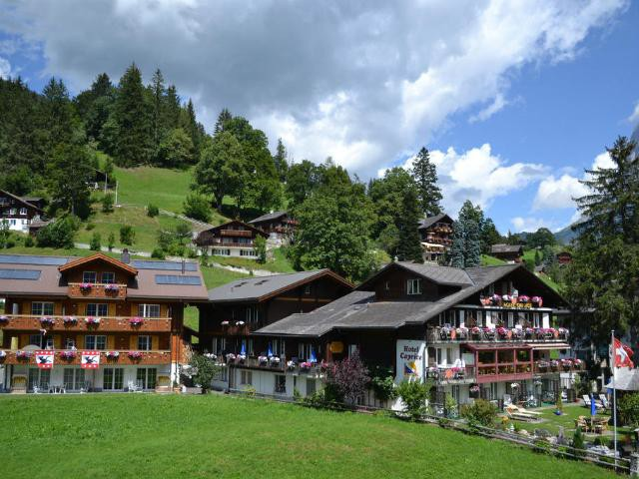
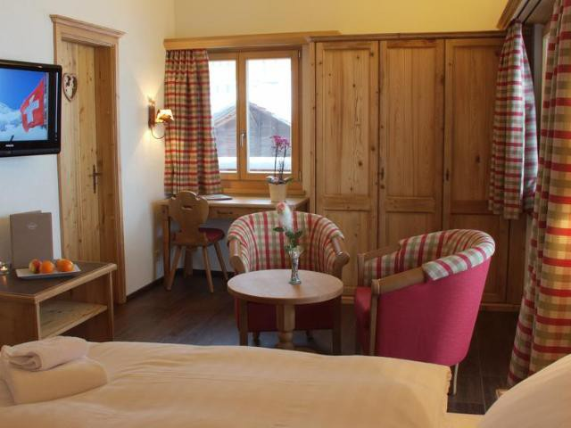
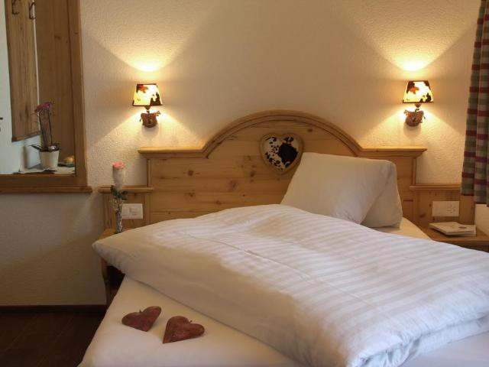

The Hotel Caprice boasts a perfectly quiet, but very central location in the mountain village of Grindelwald in the Bernese Oberland, and offers you impressive views of the mountains.

Enjoy comfortable rooms with a balcony or a garden terrace and the beautiful views of the majestic mountains.

There is also a wonderful garden with deck chairs, wicker chairs, beautiful floral decorations and a unique view of the famous North Face of the Eiger.

Small snacks are served at the property, while guests get a discount on a 5-course menu at the Hotel Alpina, which is 100 m away.

The cable cars and buses are only a few steps away. Upon request and availability parking spaces in an underground car park are at your disposal at an additional cost.

The spa offers a hot tub, a sauna, a steam bath, a massage shower, a herbal bath, a solarium and professional massages.

MONTREUX: EUROTEL MONTREUX 4*
www.eurotel-montreux.ch/en/ Booking.com review (2016-12-06): 8.4/10
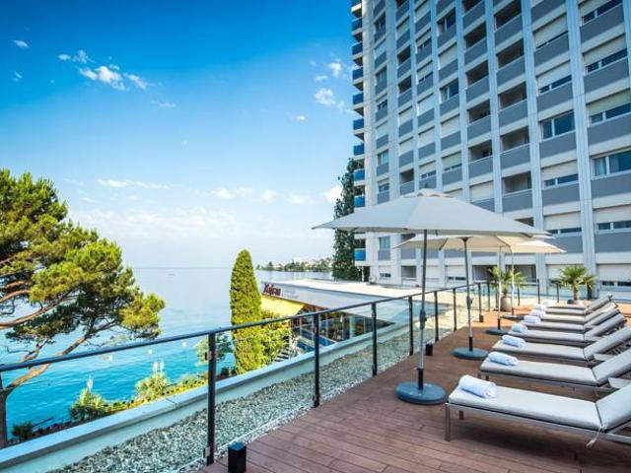
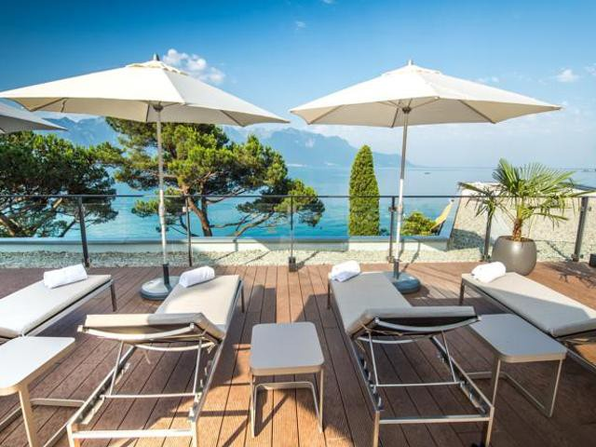
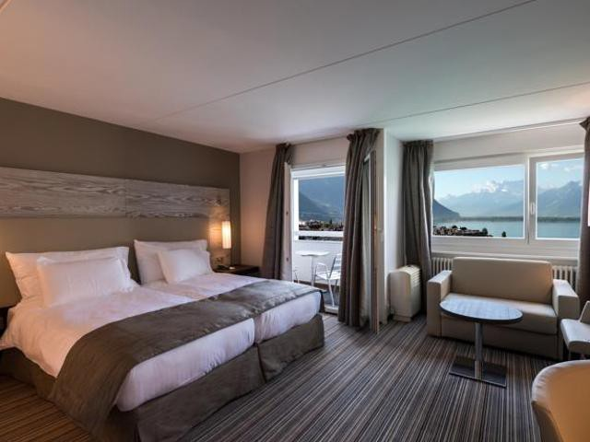

Eurotel Montreux is located right on the banks of Lake Geneva in Montreux, and offers uninterrupted views of the lake and the Alps from all rooms, as well as free WiFi access.
Rooms feature satellite TV and a minibar. Most units come with a balcony.Guests can enjoy Swiss and international cuisine in the lake-view restaurant or on the terrace, where barbecued dishes are prepared during the summer months

ZERMATT: ARCA SOLEBAD WELLNESS & SPA 3*
http://www.arca.ws/
Booking.com review (2018-11-09): 9.4/10
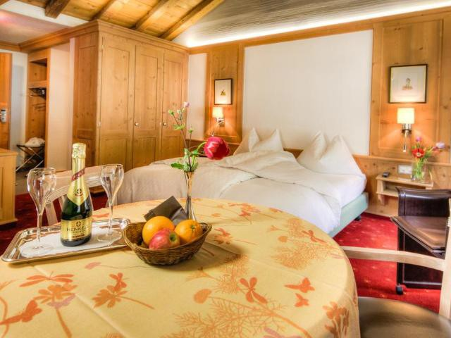
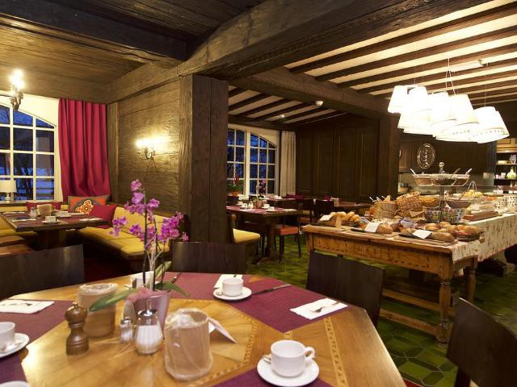
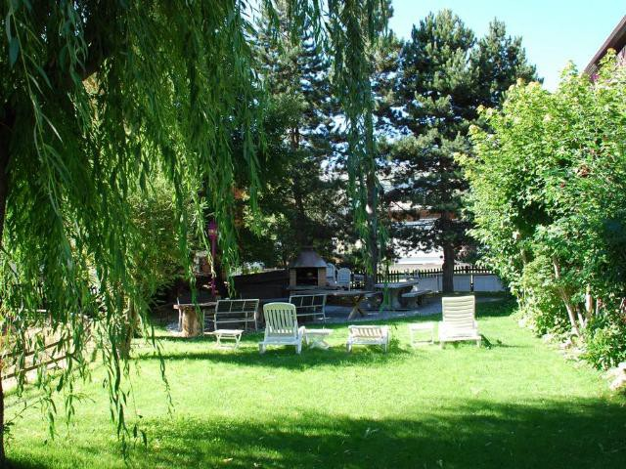

The ARCA Solebad Wellness & Spa in Zermatt is located near the centre, the station, the Gornergrat train and the Sunnegga-Rothorn train and features up-to date wellness facilities including an indoor brine pool.

All rooms in the ARCA Solebad Wellness & Spa have a balcony with mountain views and the south-facing rooms offer Matterhorn views. They all come with a kitchenette. Breakfast is served every morning.
Wireless internet is available free of charge in the entire hotel residence. The heated brine swimming pool (34°C), the steam bath and the sauna are perfect places to unwind after a day of skiing or hiking. On request and for an extra charge, massages can be organised, as well.

A tennis court and a garden with sun loungers, a barbecue, a garden table with benches and a Petanque field are available during the warmer months. A super market is located 40 m from the property.

ST.MORITZ: UNIQUE HOTEL EDEN SUPERIOR 3*
https://www.eden.swiss/en-gb Booking.com review (2017-12-18): 9.3/10
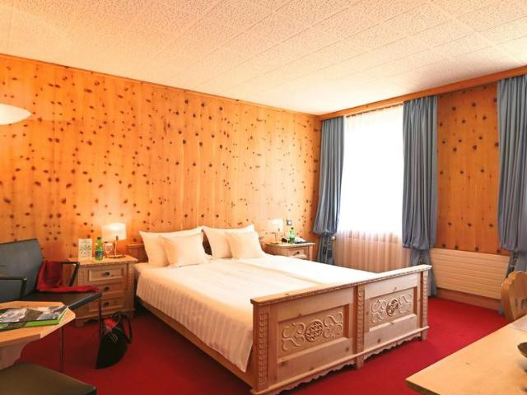
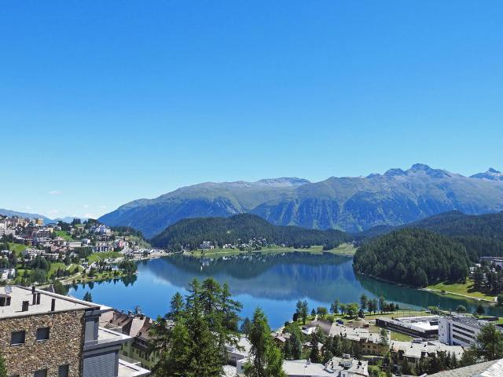
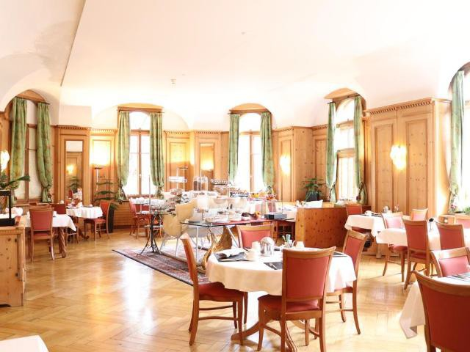

Hotel Eden is located in a historic building from the mid-19th century in the pedestrian zone in the centre of St. Moritz. It offers free Wi-Fi.

The individually furnished rooms at Hotel Eden have a bathroom with hairdryer, a seating area, and satellite TV. Most have a flat-screen TV.

Guests of the Eden can relax in a TV lounge and in the glass-covered courtyard.

A large breakfast buffet is served every day in the elegant, wood-panelled breakfast room. In the afternoon, tea, coffee and cakes are served in Hotel Eden's light-flooded tearoom which is decorated with an open fireplace and exclusive antiquities.

Free shuttle services from the train station are available on request between 07:30 and 18:30.

ZURICH: HOTEL ADLER ZURICH 3*
Booking.com review (2019-11-19): 9.0/10
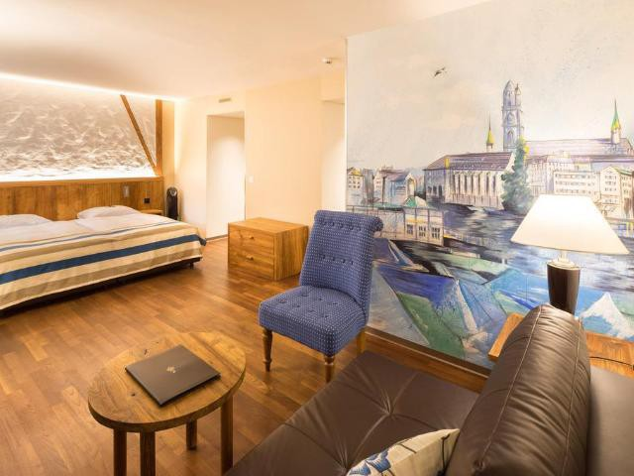
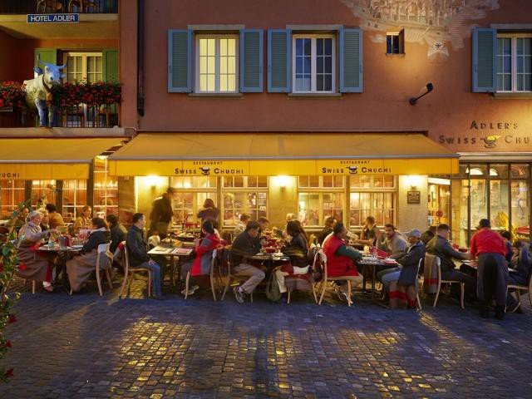
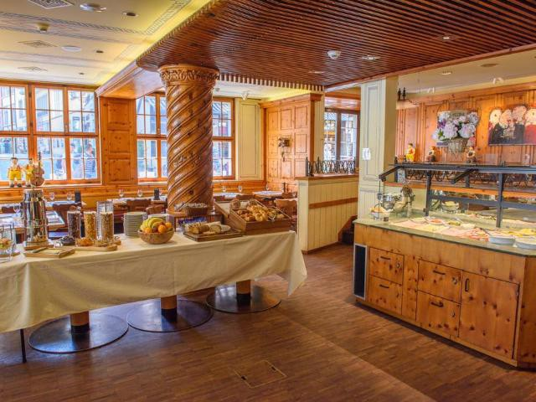

Dating back from the 16th century, Hotel Adler is a charming property in the heart of the "Niederdorf" area, Zurich´s lively and charming Old Town with its unique atmosphere.
The hotel's décor conveys a sense of style, from the private baths to the generous wall decorations portraying different views of the city. The mini-bar in the rooms is stocked with free soft drinks. Free WiFi is available in all rooms and public areas.
To dine in the "Swiss Chuchi" restaurant is to enjoy Swiss traditions first-hand. In summer, outside seating is

available. You will be surprised by the modern cuisine, featuring time-honored recipes such as the classic "Adler Cheese Fondue" or crispy "Rösti" potato pancakes.
Just a few minutes from the main sights, the Adler is just a 5-minute walk from the Bahnhofstrasse shopping street and Zurich Lake. The railway station is 2 tram stops away.

1. Zurich Old Town - City Center is a great choice for travelers interested in old-town exploration, shopping and architecture. This is our guests' favorite part of Zurich, according to independent reviews. Couples in particular like the location – they rated it 9.5 for a two-person trip.

